Lucky Light Solar Lamp Series
Technical Data Sheet

Model No: L-LLS-L003



Features:
- Super bright LED.
- Low Power Consumption.
- Long life.
- Low voltage operation at 1.2V DC.
- Nature or available for all color.

Description:
Solarpanels:monocrystalline or polycrystalline silicon(0.695±0.05W), illuminant: superbright LED, brightness: 3 white LEDS or 5 white LEDS, working hours:8hrs Material: ABS and Stainless Steel lamp, 2x1.2V AA 800 mAh Ni-MH rechargeable batteries

Application:
At a good site, the sunshine should keep at least 8 hours per day. Insufficient sunshine will affect the battery charging, then affect the lighting time of the lamp at night. So pls donot set the solar LED lamp at a place with very short sunshine time. The places like lawn, parks and some other places with long sunshine time are ideal for the solar LED lamp. At 8 hours’ sunlight shining, pls turn the switch of the solar LED lamp to be “ OFF”, which can make the power of the battery being charged to be max.

Items项目 | Model | Rating额定值 | Material材料
Storage battewry (蓄电池) | AA | 2.4V,800mAh | Ni-MH镍氢  循环次数：1000次
Solar Lamp (太阳能灯) | LED | Superbright | 寿命：50000小时
太阳能电池 monocrystalline or polycrystalline sillicon |  | (0.695±0.05W) | monocrystalline or polycrystalline sillicon(寿命：20年)
L-LLS-S201 寿命：超过5年

Notes:
Product picture: 产品图片
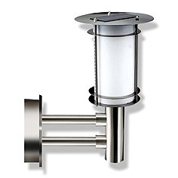
Product Dimensions: 产品尺寸(cm):21.3X34.9

